**Assisted Practice: 3.10 Initialize a Volume Restored from a Snapshot on Linux**

This section will guide you to:

* Initialize a volume restored from a snapshot

This lab has three subsections, namely:

3.10.1 Selecting the snapshot

3.10.2 Restoring volume from the snapshot

3.10.3 Pushing the files to GitHub repositories

**Step 3.10.1:** Selecting the snapshot

* Go to EC2 dashboard in EBS and click on *Snapshot*

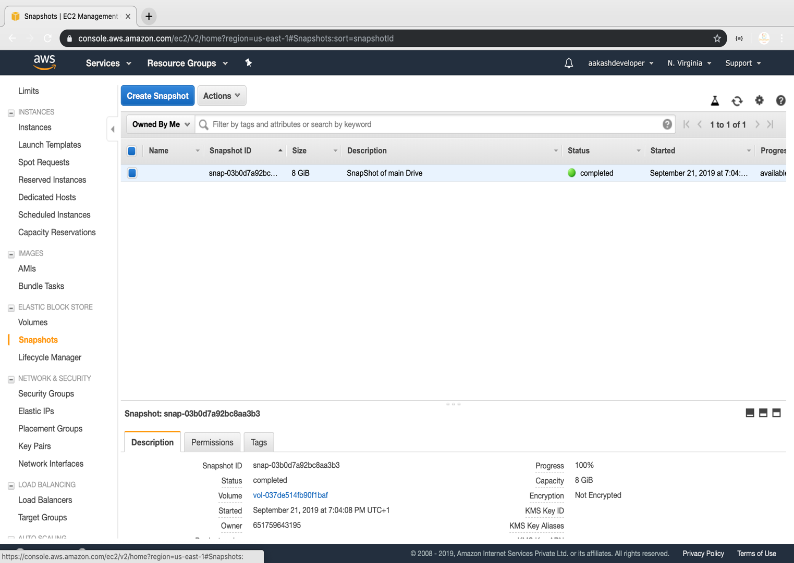

**Step 3.10.2:** Restoring volume from the snapshot

* Select the snapshot and click on *Action*

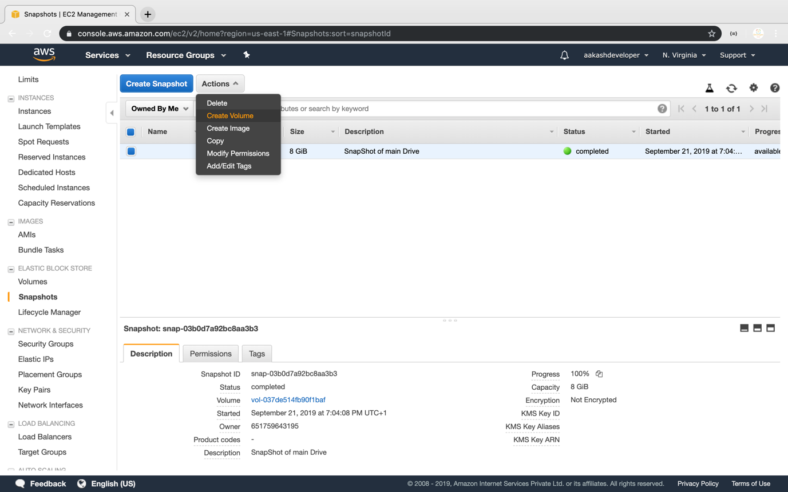

* You can specify the key and value to identify the volume

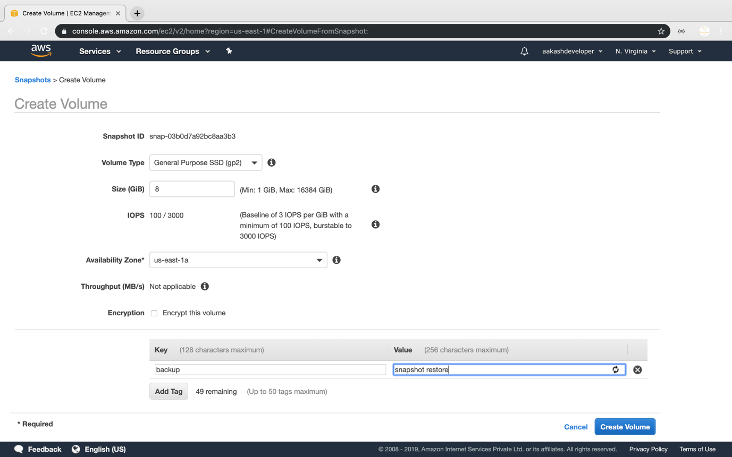

* Restore the volume from the snapshot

